**Project Design Phase-II**

**Data Flow Diagram & User Stories**

|  |  |
| --- | --- |
| Date | 03 November 2023 |
| Project Name | A CRM APPLICATION FOR WHOLESALE RICE MILL |

**Data Flow Diagrams:**

A Data Flow Diagram (DFD) is a traditional visual representation of the information flows within a system. A neat and clear DFD can depict the right amount of the system requirement graphically. It shows how data enters and leaves the system, what changes the information, and where data is stored.

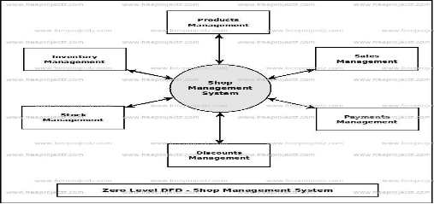

**User Stories**

Use the below template to list all the user stories for the product.

| **User Type** | **Functional Requirement (Epic)** | **User Story Number** | **User Story / Task** | **Acceptance criteria** | **Priority** | **Team Member** |
| --- | --- | --- | --- | --- | --- | --- |
| Customer | Inventory Management | USN-1 | Create a digital inventory system that includes all cosmetic products in stock, with details such as product name, brand, quantity, and expiry dates. | The system should allow the addition of new products to the inventory, including details like product name, category, quantity, price, and supplier information. | High | Manoj |
|  |  | USN-2 | Implement a barcode scanning system to quickly update the inventory when new stock arrives or when products are sold. | It should provide the ability to update existing product details such as price, quantity, and other attributes. | High | Sharma |
|  |  | USN-3 | Set up low-stock alerts to notify the store manager when a product is running low. | The system should automatically track and decrement the quantity of products when they are sold. | Low | vishwa |
|  | Sales Management: | USN-4 | Develop a point-of-sale (POS) system to process customer purchases, including tracking sales, generating receipts, and managing payment options. | The system should allow the creation of sales transactions, with the ability to add products, specify quantities, and calculate the total amount. | High | ashik |
|  | Supplier Management | USN-5 | Maintain a list of cosmetic product suppliers, including contact information, product catalogs, and pricing. | It should provide insights into inventory turnover, identifying slow-moving and fast-moving products. | High | gowtham |
|  |  | USN-6 | Automate order placement and generate purchase orders when inventory reaches a predefined reorder point. |  | Medium | Sharma |